Exam Preparation

Library

Problems for the exam preparation for the ["ASP.NET Core Fundamentals"](https://softuni.bg/trainings/4105/asp-net-fundamentals-may-2023) course @ SoftUni

**Library** is an online platform that is used to create and collect books.

# Technological Requirements and Overview

* + Use the provided skeleton – **Library_Skeleton**. All of the needed packages have been installed.

**The Technological Requirements are ABSOLUTE. If you do not follow them, you will NOT be scored for other Requirements.**

The provided skeleton consists of:

* **Areas/Identity/Pages**– you have to scaffold Identity here
* **Controllers** – you should implement the controllers logic here
* **Data** – you should hold the entities models here
* **Models** – you should implement the models here
* **Views** – you are provided with the needed views. Your task is to implement some logic regarding the logged- in/logged-out user
* **Appsettings.json** – don't forget to change the **Connection string**
* **Program.cs** – you should fulfil the security and password requirements here

**NOTE:** You should seed the database with provided in advance data regarding the **Category** and **Book** entity. In order to do this, remove the comments from the block of code in the **protected override void OnModelCreating(ModelBuilder builder)** method of the **DbContext.**

**NOTE: Don't forget to uncomment the code inside the views while you implement your logic.**

Now that you know the **Technological Requirements**, let us see what the **Functional Requirements** are.

# Identity Requirements

You should **scaffold Identity** and use the **default IdentityUser**.

Remove the unnecessary code from the **Login.cshtml** and **Register.cshtml** files and leave only the needed code in order for the app to be functioning correctly.

The **password** requirements for the **IdentityUser** are the following:

* Require confirmed account: **false**
* Require digits: **false**
* Require non-alphanumeric characters: **false**
* Required uppercase letters: **false**

# Database Requirements

The **Database** of **Library**:

## Book

* Has **Id** – a unique **integer, Primary Key**
* Has **Title** – a **string** with min length **10** and max length **50** (**required**)
* Has **Author** – a **string** with min length **5** and max length **50** (**required**)
* Has **Description** – a **string** with min length **5** and max length **5000** (**required**)
* Has **ImageUrl** – a **string** (**required**)
* Has **Rating** – a **decimal** with min value **0.00** and max value **10.00** (**required**)
* Has **CategoryId** – an **integer, foreign key (required)**
* Has **Category** – a **Category** (**required**)
* Has **UsersBooks** – a collection of type **IdentityUserBook**

**NOTE:** You are free to use your own Image URLs. If you don't want to use your own URLs, you can use the following two:

https://img.freepik.com/premium-photo/white-empty-books-mockups-template-3d-rendering_613230- 382.jpg?w=1060

https://img.freepik.com/free-photo/concept-exams-tests-space-text_185193- 79222.jpg?w=1380&t=st=1666039091~exp=1666039691~hmac=f17f061a73cc0d6055208ea2945dccd9ce2112420a5 52e7e0e9ff1ccbd9b1d52

## Category

* Has **Id** – a unique **integer, Primary Key**
* Has **Name** – a **string** with min length **5** and max length **50** (**required**)
* Has **Books** – a collection of type **Books**

## IdentityUserBook

* **CollectorId** – a **string**, **Primary Key**, **foreign key** (**required**)
* **Collector** – **IdentityUser**
* **BookId** – an **integer**, **Primary Key**, **foreign key** (**required**)
* **Book** – **Book**

Implement the entities with the **correct datatypes** and their **relations**.

**Feel free to use the new syntax for realization of the many-to-many relation without a mapping table.**

# Page Requirements

## Index Page (logged-out user)

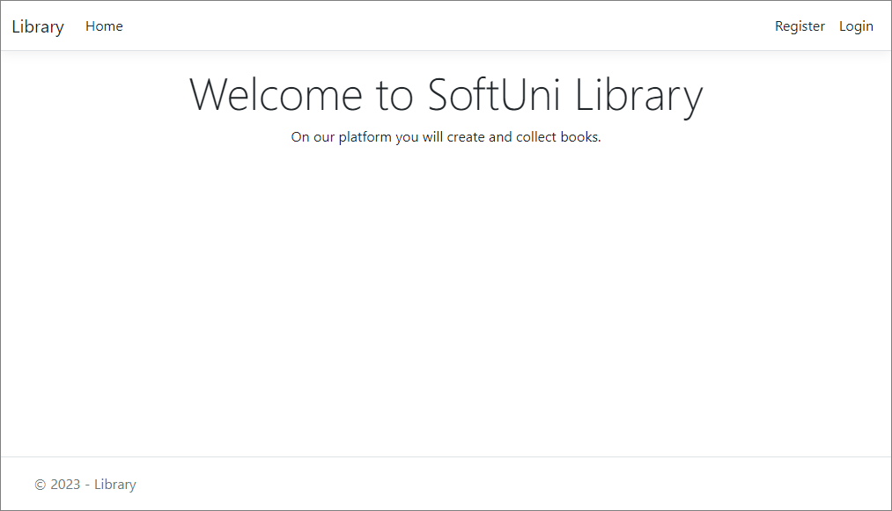

**Login Page (logged-out user)**

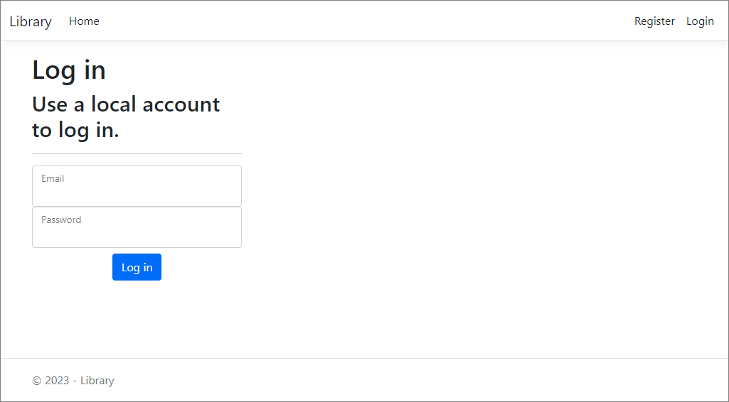

## Register Page (logged-out user)

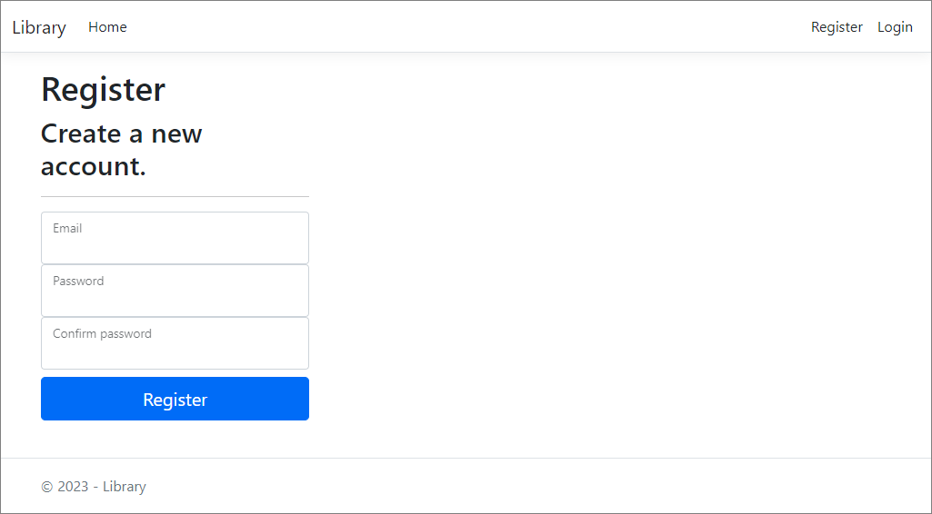

**/Book/All (logged-in user)**

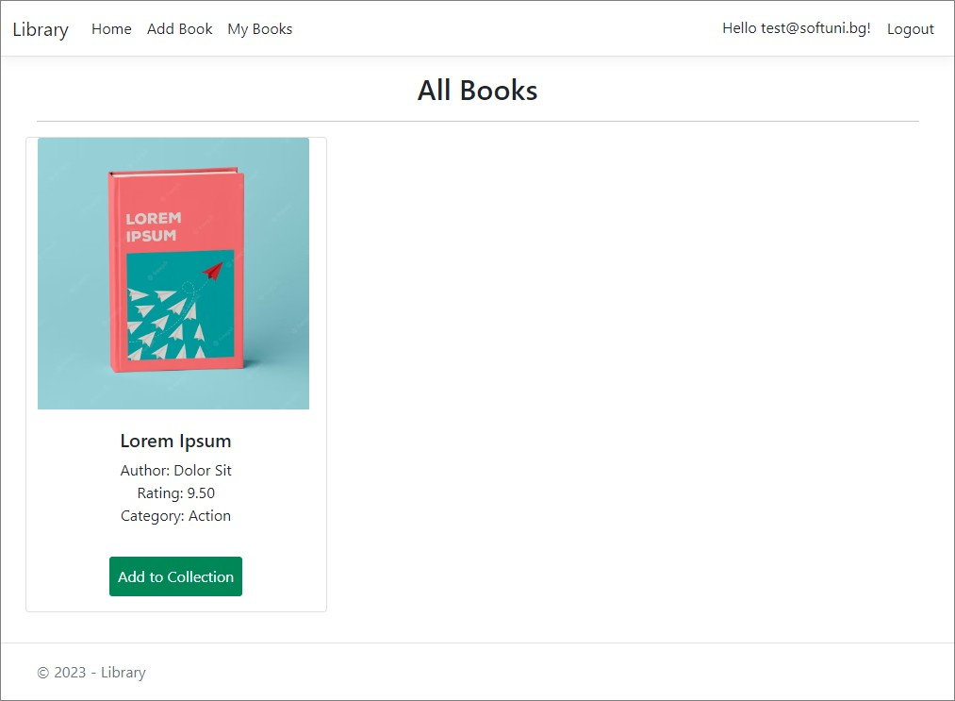

**NOTE**: If the user is **logged in** and tries to go to the **Home page**, the application must redirect them to the

**/Book/All**.

## /Book/Mine (logged-in user)

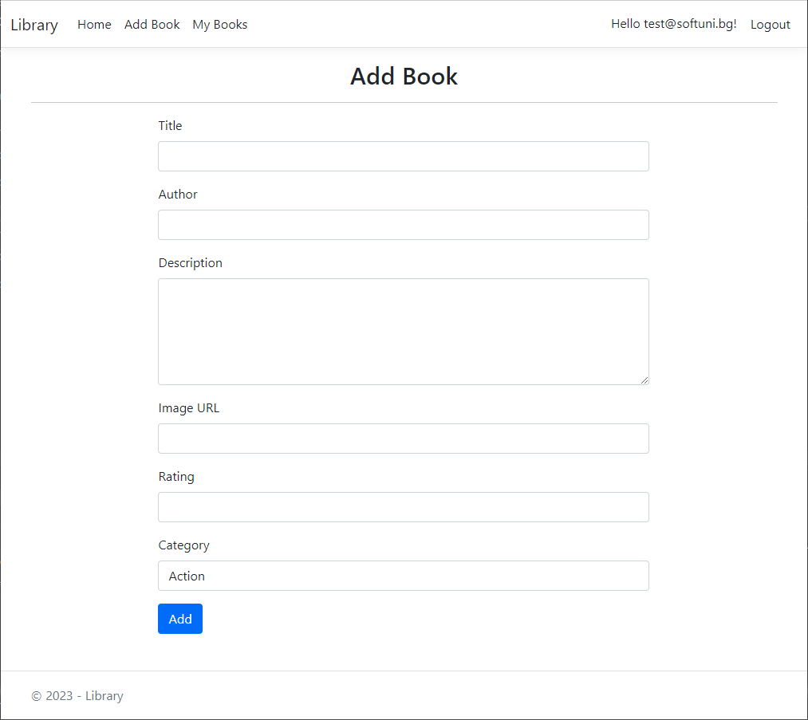**/Book/Add (logged-in user)**

## /Book/AddToCollection?id={bookId} (logged-in user)

Adds the selected book to the user's collection of books. If the book is already in their collection, it shouldn't be added. If everything is successful, the user must be redirected to the home "**/Book/All**" page.

## /Book/RemoveFromCollection?id={bookId} (logged-in user)

Removes the selected book from the user's collection of books. If everything is successful, the user must be redirected to their collection "**/Book/Mine**" page.

**NOTE**: The templates should look **EXACTLY** as shown above.

# Functionality

The functionality of the **BookLibrary** Platform is very simple.

## Users

**Guests** can **Register**, **Login** and view the **Index Page**.

**IdentityUsers** can **Add Books** and see added **Books** by all **Users** on the **Home Page (/Book/All)**. From the

**Home Page (/Book/All)**, they can also view **Info** about each one of those **Books** and **Add** them to their collection.

## Books

**Books** can be **Added** by **Users**. All created **Books** are visualized on the **Home Page (/Book/All)**, each one in its separate rectangular element.

**Books** are visualized on the **Home Page (/Book/All)** with all their information.

**Books** are visualized on the **Home Page (/Book/All)** with a button – [**Add to Collection**].

* The [**Add to Collection**] button adds the **Book** to the **User**'s collection of **Books**, **unless it is already added**.

**Users** have a **My Books** page where only the **Books** in their collection are visualized.

* The [**Remove from Collection**] button removes the **Book** from the **User**'s collection of **Books**.

## Redirections

* Upon successful **Login** of an **IdentityUser**, you should be redirected to the /**Book/All**.
* Upon successful **Creation** of a **Book**, you should be redirected to the /**Book/All**.
* Upon successful **Adding** a **Book** to the **User**'s collection, should be redirected to the /**Book/All**.
* Upon successful **Removal** of a **Book** from the **User**'s collection, should be redirected to the /**Book/Mine**.
* If a **User** tries to **add** an **already added Book** to their **collection**, they should be redirected to **/Book/All** (or just a page refresh).
* Upon successful **Logout** of a **User**, you should be redirected to the **Index Page**.
* If any of the **validations** in the POST forms **don't pass**, **redirect** to the **same page** (**reload/refresh** it).

# Security

The **Security** section mainly describes access requirements. Configurations about which users can access specific functionalities and pages:

* **Guest** (not logged in) users can access the **Index** page.
* **Guest** (not logged in) users can access the **Login** page.
* **Guest** (not logged in) users can access the **Register** page.
* **Guests** (not logged in) cannot access **Users-only** pages.
* **Users** (logged in) cannot access **Guest** pages.
* **Users** (logged in) can access the **Book/Add** page and functionality.
* **Users** (logged in) can access the **Book/All** page.
* **Users** (logged in) can access the **My Books** page.
* **Users** (logged in) can access **Logout** functionality.

# Code Quality

Make sure you provide the best architecture possible. Structure your code into different classes, follow the principles of high-quality code (**SOLID**). You will be scored for the **Code Quality** and **Architecture** of your project.

# Scoring

## Identity Requirements – 5 points Database Requirements – 10 points Template Requirements – 10 points Functionality – 50 points

**Security – 5 points**

## Code Quality – 10 points Data Validation – 10 points